Mini Project

**(2020-2021)**

**MID-TERM REPORT**

**Institute of Engineering & Technology**



**Institute of Engineering & Technology**

**Submitted by-**

**Aishwarya Singh (181500047)**

**Simran Maurya (181500714)**

**Supervised By: -**

**Mr. Anand Kumar Gupta**

**Asst. Professor**

**Mrs. Ruchi Gupta**

**Technical Trainer**

**Department of Computer Engineering & Applications**

**Contents**

Acknowledgement 3

|  |  |
| --- | --- |
| Abstract | 4 |
| 1. **Introduction** | **5**  **444** |
| 1.1 General Introduction to the topic | 5 |
| * 1. Motivation behind the project | 6 |
| * 1. Software & Hardware Requirements | 7 |
| 1. **Problem Definition** | **8** |
| 1. **Objectives** | **9** |
| 1. **Implementation Details** | **10** |
| 1. **Progress till date and the remaining work** | **11** |
| 1. **Software Design** | **12** |
| 6.1 DFD 12 | 12 |
| 6.2 Usecase Diagram | 13 |
| 1. **Some Screenshots** | **15** |
| 1. **References** | **16** |

**Acknowledgement**

It gives us immense pleasure to present the report of B. Tech Mini-Project undertaken during B. Tech Third year. We owe special debt of gratitude to Prof. Anand Kumar Gupta, Department of Computer Science & Engineering, GLA University, Mathura for his constant support and guidance throughout the course of our work. His sincerity, toughness and perseverance have been a constant source of inspiration for us.

We also take the opportunity to acknowledge the contribution of Prof. Anand Singh Jalal, Head, Department of Computer Science & Engineering, GLA University, Mathura for his full support and assistance during the development of the project.

We won’t like to miss the opportunity to acknowledge the contribution of all faculty members of the department for their kind assistance and cooperation during the development of our project. Last but not the least, we acknowledge our friends for their contribution in the completion of the project.

**Abstract**

This project was chosen as Mini-Project1 to build a seamless website to provide safe, secure and high-quality medical care, to provide healthy diet plan, to provide health related services to everybody equally, improving health related issues online at the time of pandemics and to aware people about the necessity of routine exercises in their lives. It would not only be easy to access but also pocket friendly. This would also save our time of travelling to a physician in person.

Life has become more complex. With the help of innovating inventions, many household chores can happen in a snap of time. They are convenient modes of transport that make our journey comfortable. Just as every coin has two sides, there are cons to this style of living and the most endangered one being a negative impact on our health. We have started to live a sedentary lifestyle and no longer have the time to focus on our physical fitness and mental wellbeing. To make the best use of technology, one could prefer our website to get relevant solutions to all their health issues on their fingertips.

**1.1 Introduction**

In this project titled ‘Health & Wellness’, we are going to offer people an incredible opportunity to talk and discuss about their health-related issues. People from all over the country could refer this site for their health and wellness. There are many people out there cautious for their family as well as their own health. As the famous phrase says, “Prevention is better than cure” one should stay aware of the right food, exercises that would help them forehand to avoid any intrusion of chronic disease into their lives.

There will be sections related to different ailments. A person would be able to find the section which deals with his or her ailment and disentangle the necessary precautions and medication required. One would be able to get a proper diet chart along with necessary exercise recommendations.

The medication provided on the site would come from trustworthy physicians’ prescriptions and Internet put together.

One-to-one conversation via online chatting with experienced medical practitioners would be available too.

**1.2 Motivation**

Because of the COVID-19 pandemic, people got to know how important and precious life is. People are dealing with stress and depression everyday.  Keeping that in mind our team has decided to provide a platform to people where no pandemic can peep neither today nor in future. Good nutrition is an important part of leading a healthy lifestyle. Combined with physical activity, your diet can help you to reach and maintain a healthy weight, reduce your risk of chronic disease (like heart disease and cancer), and promote your overall health.

Recent medical reports show that there has been a rise in health-related issues like metabolism diseases, joint and skeletal problems, cardiovascular diseases, hypertension and obesity. Research has proven that a healthy lifestyle like appropriate diet, satisfactory physical fitness level and a healthy weight can provide health benefits.

In summary, for many of us, the modern lifestyle and the stress it causes affects our physical, psychological and social health. Hence, it has become vital to understand the relationship and maintain the right balance. By taking the full advantage of Internet, we have decided to give each and everyone, a healthy and wealthy today.

**1.3 Hardware & Software Requirements**

* **Hardware Requirements**
* Memory 4GB RAM (or higher)
* Intel core i3 64bit Processor (or higher)
* **Software Requirements**
* VS Code
* Google Chrome
* GitHub

# 1.4 Technologies Used

* **Front- End Technology:**
* HTML5
* CSS
* Bootstrap
* JavaScript
* jQuery
* **Back-end Technology and Tools:**
* PHP
* MySQL

**2. Problem Definition**

Millions of people follow an unhealthy lifestyle. Hence, they encounter illness, disability and even death. Problems like metabolic diseases, joint and skeletal problems, cardio-vascular diseases, hypertension, overweight, and so on , can be caused by an unhealthy lifestyle.

There is merely any platform where one can explain its suffering without any hesitation, therefore this site would enact as an open forum where complete package of medication, dietary intakes and necessary exercises would be availed.

Depression is still not a recognized problem in our society and people often feel uncomfortable while discussing their problems. To resolve this major problem of being judged, we will keep their identities private.

Women related issues is still a taboo at many places. This would be a panacea to all of their problems.

1. **Objectives**

* Lowering health care costs.
* To provide safe, secure and high-quality medical care.
* To provide healthy diet plan.
* To provide health related services to everybody equally.
* Improving health related issues online at the time of pandemics.
* To aware people about the necessity of routine exercises in their lives.

1. **Implementation Details**

The task is equally divided between the two members. Since, Front-end covers 50% part of the entire project, of which 25% is designed by each of the members.

Each week a responsive layout of a particular page of the website is designed. The report of %age task completion with GitHub link and proper screenshot is being shared to the mentors via WhatsApp.

Each page consists of 9% of the entire front-end except Login and Sign Up which are 4% each. Homepage alone covers 15% of the entire front-end.

The rest 50% of the project will also be together completed by both of the members in a defined timeline in a similar manner.

1. **Progress till date and the remaining work**

* Designing of Homepage which consists 15% of the front-end is in progress.

**Software Design**

**6.1 DFD**

**Manage medicine details**

**Admin**

**Manage website details**

**Manage Customer Details**

**Timely consultation to doctors via phone calls or video calls**

**Daily healthy diet and diet when ill**

**Exercises for good health**

**Information about various diseases**

**Cautions & advices for healthy living**

**6.2 Usecase Diagram**

WEBSITE MANAGER

CUSTOMER

7. **Some Screenshots**

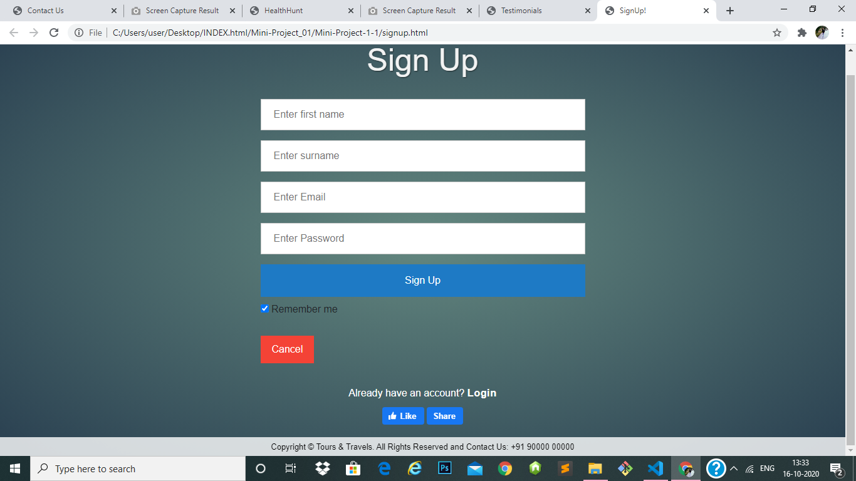

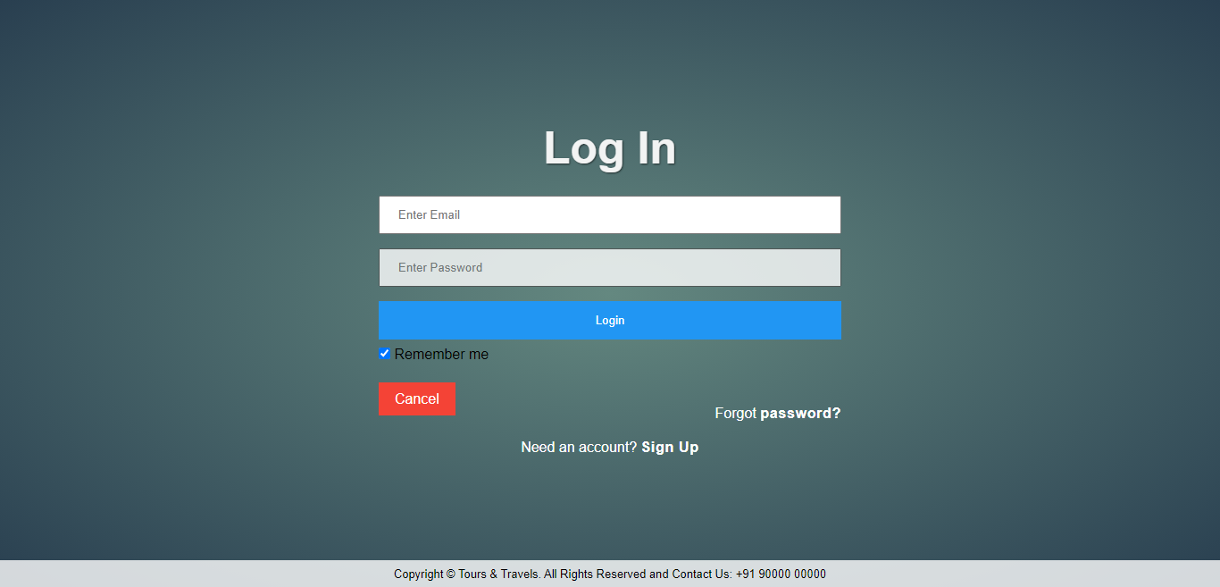

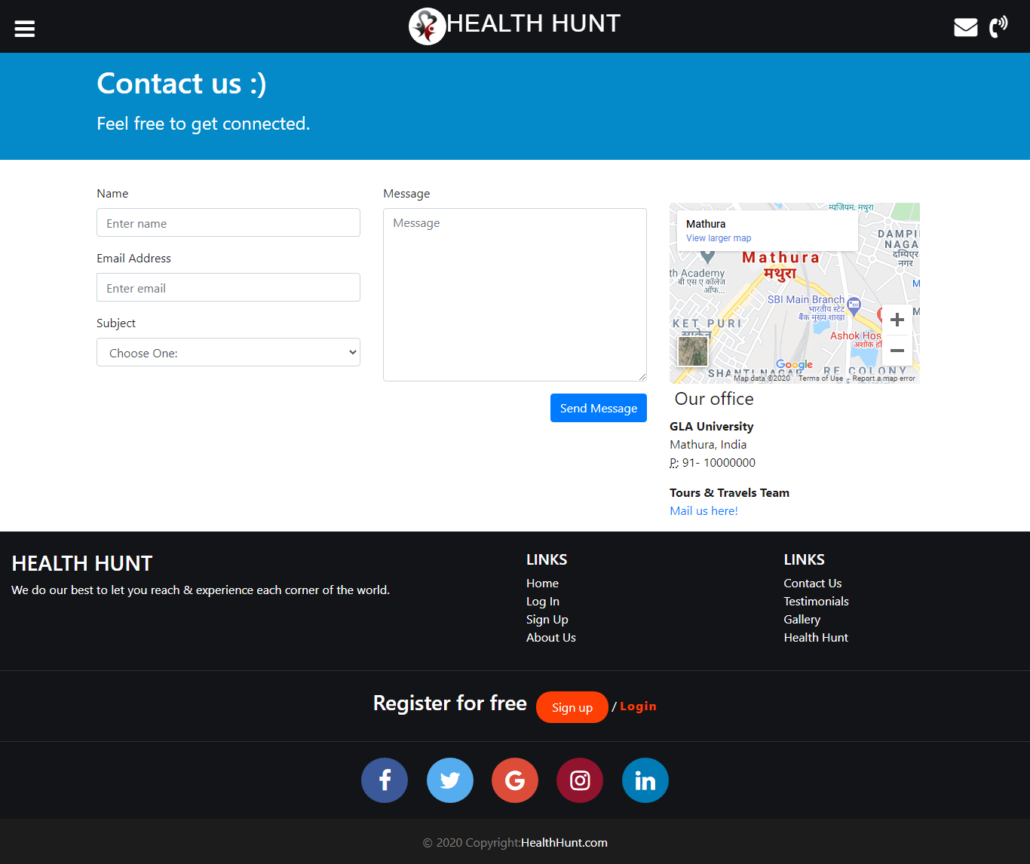

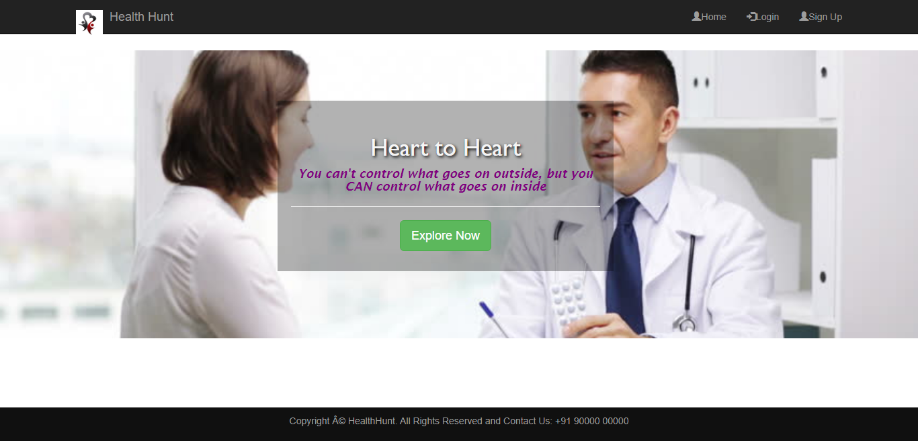

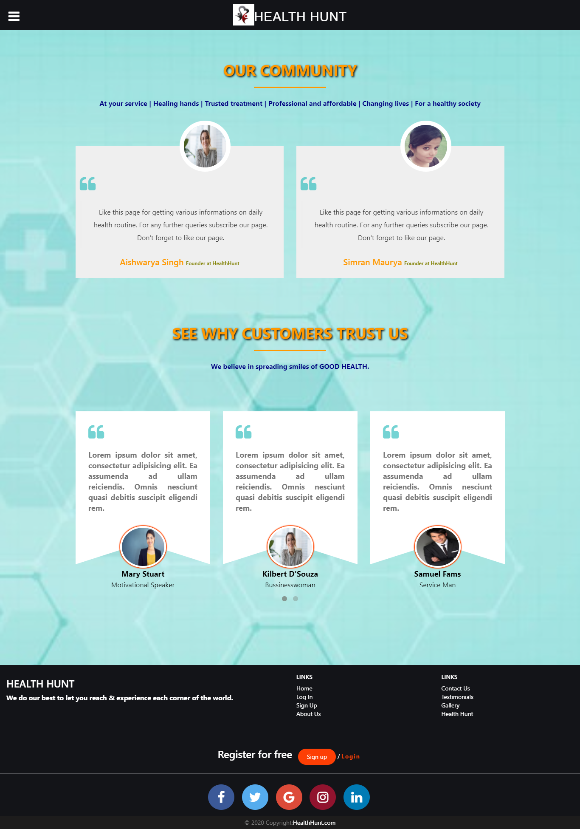

1. **References**
2. From various Health & Wellness plans initiated by the Govt. of India.
3. <https://www.webmd.com/diet/default.htm>
4. <https://www.nhp.gov.in/healthlyliving/healthy>[-diet](https://www.nhp.gov.in/healthlyliving/healthy-diet)